

American International University- Bangladesh

Software Requirement Specifications

Project Title: **Investor Finder:** *Optimizing Availability and Reliability*

Section: E Group: 07

|  |  |
| --- | --- |
| Student Name | Student Id |
| Tahmid Enam Shrestha | 20-43108-1 |
| Musfiqur Rahman Muin | 19-41514-3 |
| Asif Ahmed | 21-43388-1 |
| Sabbir Hossain Anik | 19-41410-3 |

# Introduction:

The Investor Finder system is an essential resource for entrepreneurs seeking financial help, providing an extensive overview of the company's opportunities to attract potential investors. This Software Requirements Specification (SRS) document serves as a roadmap for growth and development, ensuring consistency with the requirements of all stakeholders. The document maintains clarity and consistency by utilizing various identification numbers, names, and priorities for each requirement. Designed for possible investors, the document includes the investment opportunity, business model, market potential, competitive advantages, financial forecasts, and financial requirements. The reader could expect an organized presentation, including a use-case and class diagram, for system understanding before system utilization.

# An overview of the system:

## Description of the system:

The Investor Finder system is critical for entrepreneurs looking for financial backing. It presents a clear picture of the company's potential to attract investors. The Software Requirements Specification (SRS) document is a roadmap, ensuring the development matches stakeholders' wants. The document makes things clear and consistent by using various identifying numbers and names for each criterion. It's built for potential investors, containing crucial facts such as investment opportunities, business models, market potential, competitive advantages, financial projections, and finance needs. The well-organized text provides use-case and class diagrams to help people comprehend before implementing the system. User requirement statements are given below-

* + - As an investor, Clint, I want to be able to register on the system using my email address, creating a unique account that allows me to access the platform's features.
    - As an investor, Clint, I want the ability to log into the system securely using my registered email address and password, ensuring a personalized and protected user experience.
    - As an investor, Clint, I want to easily navigate to the home page upon logging in, where I can access relevant information, updates, and features presented in a clear and organized manner.
    - As an investor, Clint, I want the option to view my profile, showcasing my personal and professional details, achievements, and any posts or projects I have shared on the platform.
    - As an investor, Clint, I want the ability to showcase and edit my profile information, allowing me to keep my details up-to-date and accurately represent my skills and accomplishments.
    - As an investor, Clint, I want to easily search and find other inventors on the platform, using search functionality that considers relevant criteria such as skills, expertise, or project interests.
    - As an investor, Clint, I want to create and share posts about my inventions, projects, or ideas on the platform, providing a space for me to showcase my work and attract potential collaborators or investors.
    - As an investor, Clint, I want the ability to search for specific inventors or collaborators on the platform, using filters or criteria that help me discover individuals with the skills or expertise I am looking for.
    - As an investor, Clint, I want the option to view detailed information about a specific post, project, or inventor, allowing me to gather comprehensive insights before deciding to engage or collaborate.

## Use-case Diagram:

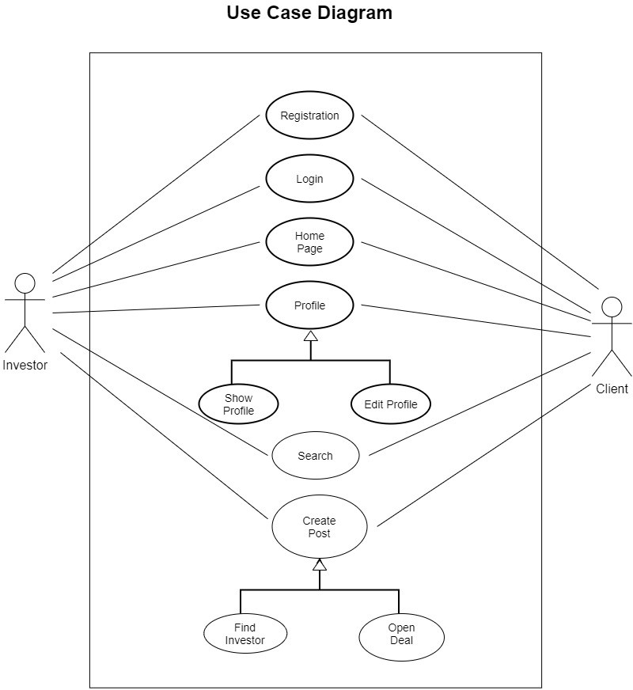

Fig 1: Use-case Diagram

# Justification:

The Investor Finder system has many advantages, the most important of which is that it helps businesses engage investors in a more streamlined and effective way. The approach enhances the likelihood that potential investors will be drawn to the company by offering a clear and compelling summary of its opportunities. This tool draws attention to the key elements that investors find appealing. It provides a clear picture of the business model, market potential, competitive advantages, and investment opportunity. The technology also helps to communicate the company's financial needs to potential investors by providing crucial financial estimates and financing requirements. Clearness and simplicity of reference are ensured by the organized organization of demands with unique identification numbers and preferences, which aids efficient project management and development. Furthermore, using use-case and class diagrams offers stakeholders a comparable illustrated overview of the system, improving understanding.

# Stakeholder analysis:

## Business Owners/Management Team:

Stake in Financial Success: Business owners want to secure investors for sustainable growth and financial success.

Utilization: Engage with the Investor Finder system to present the company's opportunities and financial projections to potential investors.

## Investors:

Stake in Profitable Ventures: Investors are keen on identifying lucrative investment opportunities.

Utilization: Access the Investor Finder system to review concise overviews of potential investment opportunities and make informed decisions.

## Development Team:

Stake in Successful Implementation: The development team is invested in effectively implementing the Investor Finder system.

Utilization: Responsible for implementing the system features outlined in the SRS document and maintaining its functionality.

## UI/UX Designers:

Stake in User Experience: Designers aim to create an intuitive and visually appealing interface for end users.

Utilization: Contribute to the UI/UX design elements to ensure a user-friendly experience for stakeholders interacting with the system.

## Project Managers:

Stake in Project Success: Project managers are concerned with the Investor Finder system's overall success and timely delivery.

Utilization: Oversee the development process, ensuring adherence to requirement priorities and timely completion.

## End Users (Potential Investors):

Stake in Informed Decision-Making: End users seek comprehensive information to make informed investment decisions.

Utilization: Interact with the Investor Finder system to gather insights into various investment opportunities businesses present.

## Regulatory Authorities:

Stake in Compliance: Regulatory authorities are interested in systems that adhere to legal and compliance standards.

Utilization: Ensure the Investor Finder system complies with relevant regulations and guidelines.

# Product Vision and Scopes:

## Product Vision:

The Investor Finder system recommends altering the environment of investment discovery by providing a cutting-edge platform for businesses and potential investors. We aim to establish a streamlined and transparent ecosystem where business owners can smoothly present their prospects and investors can make well-informed judgments by enabling effective communication and displaying critical financial data. The system aims to bridge the gap between opportunities and investments, ultimately generating economic growth and success for all stakeholders.

## Product Scope:

**Comprehensive Opportunity Presentation:** Provide a platform for businesses to present concise and comprehensive overviews of their investment opportunities.

**Transparent Financial Insights:** Facilitate the transparent sharing of financial projections, funding requirements, and other crucial financial data.

**User-Friendly Interface:** Ensure an intuitive and visually appealing UI/UX design to boost the user experience for business owners and investors.

**Stakeholder Collaboration:** To ensure project success, foster stakeholder collaboration, including business owners, investors, development teams, and project managers.

**Regulatory Compliance:** Implement and maintain the system in adherence to relevant regulatory standards, providing a secure and compliant environment.

**Timely Development and Delivery:** Prioritize the timely development and delivery of the Investor Finder system to suit the needs of stakeholders and end users.

**Educational Resources:** Offer resources within the system to educate potential investors about investment opportunities, market potential, and financial considerations.

# Classes for the system:

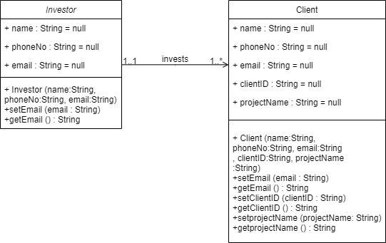

Fig 2: Class Diagram

# Component/Modules of the system:

**User Management Module:** Responsible for user-related functionalities such as registration, login, profile maintenance, and user interactions.

**Post Management Module:** Handle activities related to managing and displaying investment posts, including browsing, creating, modifying, and deleting posts.

**Interaction & Notification Module:** Manages interactions between users for investment trading, notification alerts, and interaction between post owners and potential investors.

# Functional Requirement for the system in tabular format against each module.

**User Management:**

|  |  |  |  |  |  |
| --- | --- | --- | --- | --- | --- |
| **Req ID** | **Date** | **Req Description** | **Dependencies** | **Originator** | **Testing Criteria** |
| UM1 | 2023-12-20 | User Registration |  | Stakeholder | Successful user  registration with valid data. |
| UM1.1 | 2023-12-20 | Allow new users to register using an Email  address... |  | System Architect | Successful user registration with required fields. |
| UM1.2 | 2023-12-20 | Validate user- provided Email address or Phone Number | UM1.1 | Developer | Proper validation of entered Email or Phone  Number. |
| UM1.3 | 2023-12-20 | Verify Email or Phone number using OTP | UM1.1 | System Architect | Successful verification using OTP. |
| UM1.4 | 2023-12-20 | Enforce password pattern | UM1.1 | Developer | Password pattern enforced  successfully. |
| UM2 | 2023-12-20 | User Sign-in | UM1.1 | Stakeholder | Successful user login with valid credentials. |
| UM2.1 | 2023-12-20 | Allow registered users to sign in  using Email... | UM2 | System Architect | Proper implementation of user sign-in  functionality. |
| UM2.2 | 2023-12-20 | Enable recovery of forgotten passwords  using valid... | UM2 | Developer | Successful recovery of forgotten password. |

**Post Management:**

|  |  |  |  |  |  |
| --- | --- | --- | --- | --- | --- |
| **Req ID** | **Date** | **Req**  **Description** | **Dependencies** | **Originator** | **Testing**  **Criteria** |
| PM1 | 2023-12-20 | Browse Post | UM2 | Stakeholder | Successful viewing of  available posts. |
| PM1.1 | 2023-12-20 | Allow users to view investigation- finding posts | PM1 | System Architect | Proper display of investigation- finding posts. |
| PM1.2 | 2023-12-20 | Supply a 'Show more' option to view the full  post... | PM1.1 | Developer | Successful display of full post details. |
| PM2 | 2023-12-20 | Reporting | UM2 | Stakeholder | Proper reporting functionality for inappropriate  posts. |
| PM2.1 | 2023-12-20 | Enable users to report a post as inappropriate | UM2 | System Architect | Successful reporting of inappropriate  posts. |
| PM2.2 | 2023-12-20 | Accessible through the three-dot menu on top- right... | PM2.1 | Developer | Proper accessibility and functionality of reporting  choice. |
| PM3 | 2023-12-20 | Investment Post | UM2 | Stakeholder | Successful creation and update of investment  posts. |

|  |  |  |  |  |  |
| --- | --- | --- | --- | --- | --- |
| PM3.1 | 2023-12-20 | Allow users to post with required investment... | UM2 | System Architect | Properly create investment posts with necessary  details. |
| PM3.2 | 2023-12-20 | Enable users to update or delete their investment... | PM3.1 | Developer | Successful update and deletion of investment posts. |

**Interaction & Notification:**

|  |  |  |  |  |  |
| --- | --- | --- | --- | --- | --- |
| **Req ID** | **Date** | **Req Description** | **Dependencies** | **Originator** | **Testing Criteria** |
| IN1 | 2023-12-20 | Investment Dealing | UM2, PM3.1 | Stakeholder | Successful sending and confirmation of  deal requests. |
| IN1.1 | 2023-12-20 | Enable users to send deal requests for investing... | IN1 | System Architect | Proper functionality and notification for deal requests. |
| IN1.2 | 2023-12-20 | Notify investment post owners and require... | IN1.1 | Developer | Successful notification and confirmation process for deal  requests. |
| IN1.3 | 2023-12-20 | Allow communication between post owner and... | IN1.2 | System Architect | Successful communication between post owner and  investor. |
| IN1.4 | 2023-12-20 | Support multiple deal  requests for individual... | IN1.1 | Developer | Proper handling of multiple deal  requests for the same post. |
| IN1.5 | 2023-12-20 | Enable users to rate each other after deal... | IN1.4 | System Architect | Successful rating system implementation  for deals. |
| IN2 | 2023-12-20 | User Profile | UM2 | Stakeholder | Proper display  and editing of |

|  |  |  |  |  |  |
| --- | --- | --- | --- | --- | --- |
|  |  |  |  |  | user profile  information. |
| IN2.1 | 2023-12-20 | Allow users to view and edit profile information | UM2 | System Architect | Successful display and editing of  profile information. |
| IN2.2 | 2023-12-20 | Provide access to posted and dealing... | IN2.1 | Developer | Proper access and display of posted and dealing  information. |
| IN3 | 2023-12-20 | Notifications | UM2, IN1.1 | Stakeholder | Successful notification for messages and warnings. |
| IN3.1 | 2023-12-20 | Send notifications for received  messages or... | IN3 | System Architect | Proper sending of notifications for messages  and warnings. |
| IN3.2 | 2023-12-20 | Notify users of any warnings from the  admin | IN3.1 | Developer | Successful notification for admin  warnings. |

# Non-Functional Requirements for the System

**Usability:** The software shall have a user-friendly interface that is easy to understand and use. The simple design allows users to post and negotiate for investments effortlessly utilizing the system. The software shall offer feedback to users, including confirmation of successful activities and error messages for unsuccessful ones. The features are created and built so that consumers can quickly grasp them by seeing them. It shall provide a mobile-friendly interface for users to access the system from their smartphones and tablets.

**Security:** This attribute restricts access to the system exclusively to authorized users. Users must possess a valid email address or phone number and the appropriate passwords to sign in. The significance of this characteristic's role in guaranteeing system security is that allowing only individuals to use the system contributes to safeguarding data from unauthorized parties. This function is aimed at boosting overall security.

**Reliability:** These traits relate to accurately and effectively performing the system's intended functions. The system is meant to accurately serve users' desired functions, such as browsing investment posts, without causing mistakes. It guarantees that the user gets the correct

output. The system also doesn't take much time to respond to the user's action. The software shall include a backup and disaster recovery plan to ensure that data is not lost during a system breakdown or disaster. Additionally, the software should have a system monitoring plan to detect and rectify issues as they develop, adding to continued operational stability.

**Flexibility:** The program shall be versatile enough to accept different events and price schemes. The system is adaptable to alter. It is flexible for additional capabilities and easy to add code to the system and upgrade it for new features. The technology shall allow organizers to choose their preferred payment gateway and currency.

**Maintainability:** The system must be easy to maintain and update, with clear documentation and guidance for troubleshooting and debugging. It relates to how quickly a software system can be edited, enhanced, and modified over time without creating flaws or having undesired side effects.

**Testability:** The program shall be built to aid automated testing, including unit testing and acceptance testing. The program shall include tools and facilities to help developers and testers design and manage test cases. The program shall enable easy debugging and troubleshooting of difficulties during a tasting. It means the work necessary to discover and fix bugs and modify functionality.

**Testability:** The software shall be optimized for efficient use of system resources, including CPU, memory, and network bandwidth. The software should use caching technologies to lessen the burden on the system and enhance response time. The software shall be developed to minimize data duplication to reduce storage requirements.

**Robustness:** the software shall be designed to manage unexpected inputs and edge cases without crashing or calculating data. The software shall employ defensive programming techniques to ensure that it can gracefully handle faults and exceptions. The software

Shall have a monitoring plan to detect and respond to security breaches or other threats.

**Correctness:** The system must ensure that all user and event data is accurately recorded and saved. The system must conduct all operations correctly and consistently. The system must give users accurate and timely information about events.

**Reusability:** The system must be built to be reusable, with modular components that can be quickly altered or extended for new use cases. The system must be interoperable with many platforms and technologies to enable future integration with other systems.

**Scalabilities:** The system must be designed to scale up or down as necessary to handle fluctuations in demand. The system must be able to accept future growth and able to enable extra features and capabilities.

# System’s Requirements:

* 1. **User Registration** (Functional Requirements)
     1. The system will allow new users to register into the system using an
     2. Email address or phone number, password, and NID.
     3. Users must use a valid Email address or Phone number.
     4. The user’s Email or Phone number will be verified using OTP.
     5. Password must be appropriately followed. Pattern 5.
     6. The login credentials (username and password) will be verified with database records.
     7. If the login is successful, the home page of the user account will be displayed.
     8. If the username and or password has been inserted wrong, the

random verification code will be generated and sent to the user’s email

address by the system to retry login.

* + 1. If the number of login attempts exceeds its limit (3 times), the system shall block the user account login for one hour [Optional function]

## Priority Level: High

**Precondition:** The user must have a valid Email address or Phone Number and NID.

## Cross-references: N\A

* 1. **User Sign-in** (Functional Requirements)
     1. Registered users can sign into the system using their Email address or Phone number and password.
     2. Users can recover forgotten passwords by providing a valid OTP sent to their Email address or Phone Number.

## Priority Level: High

**Precondition:** The user must have registered in the system.

**Cross**-**references:** 10.1

* 1. **Browse Post** (Functional Requirements)
     1. Users can view investigation-finding posts.
     2. By clicking the ‘Show more’ button, users can view full post details.

## Priority Level: Low

**Precondition:** The user must be signed into the system.

## Cross-references: 10.2

* 1. **Report Post** (Functional Requirements)
     1. Users can report a post as inappropriate by using the three-dot menu on the top-right corner.

**Priority Level:** Medium

**Precondition:** The user must be signed into the system

**Cross**-**references:** 10.2,10.5

* 1. **Post for Investment** (Functional Requirements)
     1. Users can post the required investment details and amount.
     2. Users can update or delete the post form profile section that contains investment posts.

## Priority Level: High

**Precondition:** Users must be signed into the system.

## Cross-references: 3.2

* 1. **Investment Dealing** (Functional Requirements)
     1. Users can send a deal request for investing to an investment post by clicking ‘Deal’ button from post.
     2. Investment post owners will be notified and have to confirm or reject the deal requests.
     3. Dealing requests will remain pending if the post owner does not accept or reject the post.
     4. Post owner and investor can also contact each other through a messaging System.
     5. Multiple deal requests can be made for individual investment posts.
     6. Users can rate each other after deal confirmation.

## Priority Level: High

**Precondition:** The user must be signed into the system.

**Cross**-**references:** 10.2,10.5,10.7

* 1. **User Profile** (Functional Requirements)
     1. Users can view and edit profile information from the Profile page.
     2. Users can also previously post and deal with information from their profile.

**Priority Level:** Medium

**Precondition:** Users must be signed into the system

## Cross-references: 3.2

* 1. **User Report:** (Functional Requirements)
     1. Users can report to each other from their user profile with a message.

## Priority Level: Low

**Precondition:** The user must be signed into the system.

**Cross**-**references:** 3.2,3.7

* 1. **Notification** (Functional Requirements)
     1. Notification will be sent if the user receives any message or he/she gets any investment dealing with requests.
     2. Users will also be notified if they get any warning from the admin.

**Priority Level:** Medium

**Precondition:** Users must be signed into the system

**Cross**-**references:** 3.3,3.6

* 1. **Feedback** (Functional Requirements)
     1. System visitors can send feedback and opinions about the system

**Priority Level:** Medium

**Cross**-**references:** 3.2,3.7

* 1. **Security Features** (Functional Requirements)
     1. The software shall have robust security features to protect user data.
     2. The software shall use encryption to protect sensitive data and payment information.

## Priority Level: High

**Precondition:** User inputs or accesses sensitive information in the system.

# 11.0 Manpower Requirement for implementation

The workforce requirements for implementing software requirements in software engineering involve several factors and considerations. Workforce needs can depend on the project's complexity, the technologies involved, and the development methodology chosen. Example:

**Project Size and Complexity:** Larger and more complex projects require more workforce. Evaluate the scope of the project, the number of features, and the overall complexity of the software.

**Development Methodology:** The chosen development methodology can impact workforce requirements. For example, agile methods may require similar, cross- functional terms, while traditional methods may have significant, more specialized teams.

**Technology Stack:** The technologies used in the project influence the skill sets required. Evaluate the need for expertise in specific programming languages, frameworks, databases, and other technologies.

**Skill Sets:** Identify the required skill sets for the project, such as software development, database design, testing, and project management. Ensure that the term has the expertise to handle the various aspects of the project.

**Timeline and Deadlines:** The project timeline and deadlines are crucial in determining the required workforce. Tight schedules may require more resources to meet deadlines.

**Roles and Responsibilities:** Define the roles and responsibilities of team members, including developers, testers, analysts, and project managers.

**Collaboration and Communication:** Effective communication and collaboration are essential. Consider the need for collaboration tools, meetings, and coordination efforts, and allocate resources accordingly.

**Training and Ramp-up time:** Factor in any training or ramp-up time required for team members to become familiar with new technologies or methodologies.

**Quality Assurance and Testing**: Allocate sufficient resources for quality assurance and testing activities. Testing is a critical phase in software development and requires dedicated workforce.

**Contingency Planning:** Consider unexpected challenges and the need for contingency planning. Having some buffer in terms of workforce can help address unforeseen issues.

**Documentation and Reporting:** Include resources for documentation and reporting, as these activities are crucial for maintaining a clear understanding of software requirements.

**Customer Support and Maintenance:** If ongoing customer support and maintenance are part of the project, ensure that resources are allocated for post-implementation activities.

# 12.0 Budget:

## Cost Description:

* Personnel Costs are estimated at $24,000, assuming an average hourly rate of $12 per hour per person.
* Development and Implementation costs are estimated at $18,000.
* Infrastructure Costs are estimated at $6,000.
* Testing and Quality Assurance costs are estimated at $3,600.
* Project Management costs are estimated at $2,400.
* Contingency is set at $1,800 (10% of the total).
* Other Costs (Training, Legal) are estimated at $1,200.
* Post-Implementation Support is estimated at $3,000.

|  |  |
| --- | --- |
| **Category** | **Estimated Cost** |
| 1. Personal Cost | $24,000 |
| 2. Development and  implementation Cost | $18,000 |
| 3. Infrastructure Cost | $6,000 |
| 4. Testing and Quality Assurance | $3,600 |
| 5. Project Management | $2,400 |
| 6. Contingency | $1,800 |
| 7. Other Costs (Training, Legal) | $1,200 |
| 8. Post-Implementation Support | $3,000 |
| **Total** | **$60,000** |

# Constraints of this documents

**Design Tool Constraint:** The document restricts design to Canva. This constraint causes challenges for developers who may prefer different tools.

**Language and Technology Specification:** Required languages (HTML, PHP, JavaScript) restrict developer flexibility, highlighting security validation.

**Static Requirement Numbers:** The numbers must remain fixed even when sections or requirements change. While ensuring consistency, this constraint complicates document management when modifications are made/

# Conclusion:

In conclusion, as specified in the Software Requirements Specification (SRS) document, the Investor Finder system is a vital software solution. The plan will simplify relationships between businesses seeking finance and possible investors by addressing specified characteristics, business requirements, and user functionalities. Keeping to recognized patterns, the document appeals to a target audience of potential investors, providing a methodical review of investment prospects and essential information. Emphasizing user- friendly design and complete functionality, the Investor Finder system shows potential as an effective and convenient platform within the investment landscape.